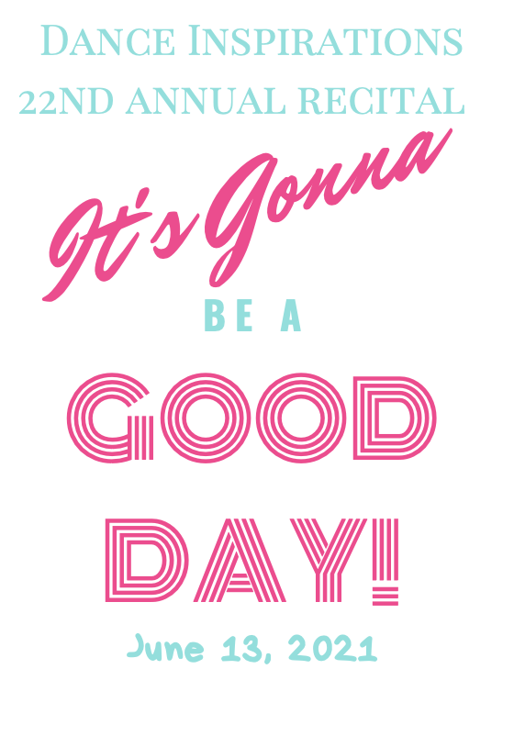

SHOW 1 at 11:00am

- Into the Woods - Musical Theater Jazz ‑ Teacher: Meghan Demers
Vivian Gray, Audrey Malone, Allyson Moore, Rylynn Nagy, Abigail Poole & Abby Porter

- Rhinoceros Tap – Tap - Teacher: Amy Blanchard
Hazel Hildreth, Meredith Lemire & Sarah Rogenski

3. Favorite Things – Ballet - Teacher: Kate Weston
Megan Flaherty, Avery Foor, Gianna Kelly & Cloe Rocheville

- With My Foot - Tap - Teacher: Carolyn Coskren & Kate Weston
Camdyn Caldwell, Alice Heard, Zelda Heard, Lacey Low, Logan Pitts, Anya Yadav & Devi Yadav

- Survivor- HIP‑HOP - Teacher: Meghan Demers
Averie Greenwood, Kennedy Locke & Abby Porter

- Monkey See, Monkey Do! Tap - Teacher: Melanie Najarian
Charlotte Parda, Henry Pitts, Sarah Rogenski & Auroya Tonkin

- Have it all – Teacher: Carolyn Coskren
Juliette Anderson

- Switch - HIP‑HOP - Teacher: Kaleigh Nelson
Ally Boyer, Lorelei Dodge, Meghan Fossum, Rylee Greenwood, Olive Hildreth, Gianna Kelly, Olivia Pedemonti & Georgia Skafidas
SHOW 2 at 12:00

- Tap Those Toes - Teacher: Juliette Anderson
Paisley Bennett, Lydia Foor, Liberty Lobsinger, Paislee Mulcahy, Bria Pratte & Penny Schools

- Descendants Mash Up ‑ Teacher: Meghan Demers
Harper Clark, Sutton DeRoche, Jocelin Henley, Amelia Kerr, Molly Kerr, Juliana Maguire & Julia Schools

3 This Little Piggy ‑ Teacher: Carolyn Coskren
Hazel Cabral, Kace Duckrow Fonda, Rye Duckrow Fonda, Sadie Fucella, Lydia Kaempfer, Lydia Miner, Delaney Nelson & Blair Uhouse

4 Dance with Somebody- Teacher: Kenzie Thorpe
Delaney Afflick, Emilee Burgess, Kylie Crowe, Gavin Johnson, Gabriella Kangas & Norah Lanigan

5 Sea Cruise ‑ Teacher: Amy Blanchard
Serenity Barberian, Aila Bascelic, Juliet Delude, Emerson Herr, Hannah Kerr, Kelsea Moore & Aria Nagy

6 Girls Just Wanna Have Fun ‑ Teacher: Meghan Demers
Ally Boyer, Sutton DeRoche, Juliette Doherty & Penny Schools

7 Lady Bug Boogie ‑ Teacher: Carolyn Coskren
Kamryn Cabral, Rye Duckrow Fonda, Serena LaPlante, Eloise Miller, Macie Palmisano, Bria Pratte, Charlotte Towle & Cora Ward

8 Hey Good Lookin' ‑ Teacher: Carolyn Coskren
Delaney Afflick, Emilee Burgess, Kylie Crowe, Gavin Johnson, Gabriella Kangas & Norah Lanigan

Show 3 at 1:00 pm
- We Got The Beat - Teacher: Carolyn Coskren
Eva Ashworth, Ally Boyer, Aleksandra Graham-Binder, Caia Kimball, Mallory Sanford, Addison Sargent & Jada Walker

- Once Upon A Dream - Teacher: Amy Blanchard
Luke Ashworth, Adeline Bergeron, Emaleigh Boucher, Adelyn Crowley, Elaine Gilchrist Emerson, Herr, June O’Brien, Emersyn Scroggins, Kevin Ward & Norah Wilkening

- Hit Me Up - Teacher: Laurie Lucier
Reese Cutchens, Caleigh Epple, Thomas Henley, Madelyn Robert, Norah Robert, Pemberley Scroggins & Olivia Thibeault

- Hey Good Lookin' ‑ Hey Good Lookin' ‑ Teacher: Carolyn Coskren
Delaney Afflick, Emilee Burgess, Kylie Crowe, Gavin Johnson, Gabriella Kangas & Norah Lanigan

- Opus 72 - Teacher: Laurie Lucier
Eva Ashworth, Layla Hildum, Addison Sargent, Jada Walker

- Can't Stop This Feeling - Teacher: McKenzie Thorpe
Addy Abbott, Mia Milicevic & Mallory Sanford

- Have it all
Juliette Anderson

- Neutron Dance - Teacher: Carolyn Coskren
Ally Boyer, Jocelin Henley, Caia Kimball, MJ Pineo & Addison Sargent

- Fabulous – Teacher Meghan Demers
Eva Ashworth

- Going to the Zoo - Teacher: Carolyn Coskren
Charlotte Dunn, Reese Gallagher, Lilah Hall, Madison Kallelis, Elijah Lister, Charlotte Robert & Zoey York

- Monkey Monkey - Teacher: Amy Blanchard
Luke Ashworth, Adeline Bergeron, Emaleigh Boucher, Adelyn Crowley, Elaine Gilchrist, Emerson Herr, June O’Brien, Emersyn Scroggins, Kevin Ward & Norah Wilkening
12 Exceptional - Teacher: Melanie Najarian
Eva Ashworth, Aleksandra Graham-Binder, Caia Kimball, Mallory Sanford, Addison Sargent & Jada Walker

Show 4 at 2:00pm

1 Heartbeat DrumBeat ‑ Teacher: Carolyn Coskren
Isabella Delude, Avah Rose Fiske, Ada Fisher Kinsley Foss, Ainsley Herr, Isabelle Huntley, Macie Pampel, Ava Perrault & Riley Podraza

- Beautiful ‑ Teacher: Melanie Najarian
Delaney Afflick, Eva Ashworth, Aleksandra Graham‑Binder & Norah Lanigan

- Crazy In Love ‑ Teacher: Carolyn Coskren
Juliette Anderson, Jillian Calangelo, Kaleigh Nelson & Damien Saltmarsh

- Alphabet Boogie - Teacher: Carolyn Coskren & Kate Weston
Gigi Allen, Sylvia Fisher, Paytin Flournoy, Delaney Gilbert, Lucy Liane, Lillian Norko, Rowan Palys, Finlay Perry & Lydia Pinette

- Walk the Dinosaur ‑ Teacher: Meghan Demers
Isabella Delude, Avah Rose Fiske, Avery Foor, Kinsley Foss, Ainsley Herr, Isabelle Huntley, Macie Pampel & Riley Podraza

8 The Royal Princess
Eva Ashworth

9 Got A Feeling
Delaney Afflick

10 Pachelbel's Canon in D ‑ Teacher: Amy Blanchard
Isabella Delude, Sutton DeRoche, Avah Rose Fiske, Constance Fisher, Kinsley Foss, Ainsley Herr, Isabelle Huntley & Riley Podraza

11 I Miss You, I'm Sorry – McKenzie Thorpe
Damien Saltmarsh

12 Burn It Up ‑ Teacher: Meghan Demers
Eva Ashworth, Benjamin Delude, Isabella Delude, Artemis Emmett, Avery Foor, Norah Lanigan & Cloe Rocheville

Show 5 at 3:00pm

- Crazy in Love ‑ Teacher: Carolyn Coskren
Juliette Anderson, Jillian Calangelo, Kaleigh Nelson & Damien Saltmarsh

- What’s This? - Teacher: Carolyn Coskren
Caleb Anderson

3 Tiny Dancer ‑ Teacher: Melanie Najarian
Delaney Afflick, Norah Lanigan & Brynna Streeter

4 Fabulous Feet – Meghan Demers
Gavin Johnson

5 Memories‑ Teacher: Laurie Lucier
Caleb Anderson, Jillian Calangelo, Keisha Johnson & Damien Saltmarsh

6 Have it all – Teacher: Carolyn Coskren
Juliette Anderson

7 Dance with Somebody- Teacher: McKenzie Thorpe
Delaney Afflick, Emilee Burgess, Kylie Crowe, Gavin Johnson, Gabriella Kangas, Norah Lanigan, & Brynna Streeter

8 I Miss you, I'm Sorry - Teacher: McKenzie Thorpe
Damien Saltmarsh

9 Razzle Dazzle ‑ Teacher: Amy Blanchard
Artemis Emmett, Ettie Henderson, Keisha Johnson & LuLu Morrissette

10 Celebration ‑ Teacher: Meghan Demers
Addisyn Clark, Cosette Franney, Skyelee Perkins, Evelynn Sanchez, May Silverstein & Nora Winter

11 Lovely‑ Teacher: McKenzie Thorpe
Caleb Anderson, Juliette Anderson & Damien Saltmarsh

12 Dig It - Teacher: Meghan Demers
Jillian Calangelo

13 Gluck ‑ Iphigénie en Aulide, Act II: ‑ Teacher: Amy Blanchard
Delaney Afflick, Emilee Burgess, Kylie Crowe, Gavin Johnson, Gabriella Kangas, Norah Lanigan, Allyson Moore & Brynna Streeter

14 Days in the Sun ‑ Teacher: Laurie Lucier
Aila Bascelic, Camryn Cote, Alexis Durgin, Kennedy Durgin, Annabella Toribio & Valentina Toribio

15 Break Free ‑ Teacher: McKenzie Thorpe
Caleb Anderson, Juliette Anderson, Jillian Calangelo, Artemis Emmett & Damien Saltmarsh

16 Hey Good Lookin' ‑ Teacher: Carolyn Coskren
Delaney Afflick, Emilee Burgess, Kylie Crowe, Gavin Johnson, Gabriella Kangas, Norah Lanigan & LuLu Morrissette

